Real Estate Website

for

Delta

**Version 3.0 approved**

**Prepared by: Zhao Zhixun**

**<Delta>**

**<May 2021>**

**Table of Contents**

1. Overall Project Description 1

1.1. Abstract 1

1.2. Home Page 1

*1.2.1.* Header 2

*1.2.2.* *Menu* 2

*1.2.3.* Search Section 3

*1.2.4.* *Mission Statement:* 3

*1.2.5.* Recommendation and Demonstration 4

*1.2.6.* Footer section: 4

1.3. Map and Advanced Search 5

*1.3.1.* Purpose 5

*1.3.2.* Map Section 5

*1.3.3.* Advanced Search Section 6

1.4. Detailed Single Property Page 7

*1.4.1.* Purpose 7

1.5. Login and Register Page 8

1.6. Submit Property page 9

1.7. Agent Sign Up Page 9

1.8. Agent List 10

2. Database 11

2.1. Database Framework 11

2.2. Security Setting 11

2.3. Server Management 12

3. What we have not accomplished and why 13

3.2. References 14

**Revision History**

|  |  |  |  |
| --- | --- | --- | --- |
| **Name** | **Date** | **Reason For Changes** | **Version** |
| Framework | Feb 2021 | Creating homepage and cloud/database integration for website | 1.0 |
| Page Additions | Mar 2021 | Update buy/rent page and Agents list | 2.0 |
| Final Product | May 2021 | Full functionality of website is complete | 3.0 |

# Overall Project Description

## Abstract

The purpose of this document is to provide a high-level detailed description of the delta real estate website. This documentation aims to provide a comprehensive list of requirements for both the designers and the users of this real estate website.

We created this website to provide our clients with an alternate way of searching homes that are “for sale” or “for rent”. Our goal is to provide a new website that helps clients accomplish this task with an easy-to-use interface. Due to the pandemic, people may not be able to have access to live tours of properties. Our application tries to help with this problem by providing a way to search for homes and get some important information about them. To create this website, we used various programming languages, such as; HTML, JavaScript, CSS, C#, and MySQL. We created a database to store information on all of the properties and user information within our website. We used the Microsoft Azure platform to create a server that contains the database. This report aims to describe the steps we took in order to create this website.

## Home Page

The purpose of the home page is to allow our users to navigate all pages within our website. Users will be able to create an account, log in to an existing account, and search the website. It is the main hub where the user can transverse all aspects of our website. This page contains the header, menu bar, search bar, and footer.

The home page will allow users to search on various options

1. Types: Apartments, Houses, Commercial, Garages, Lots
2. Sale or Rent
3. Address

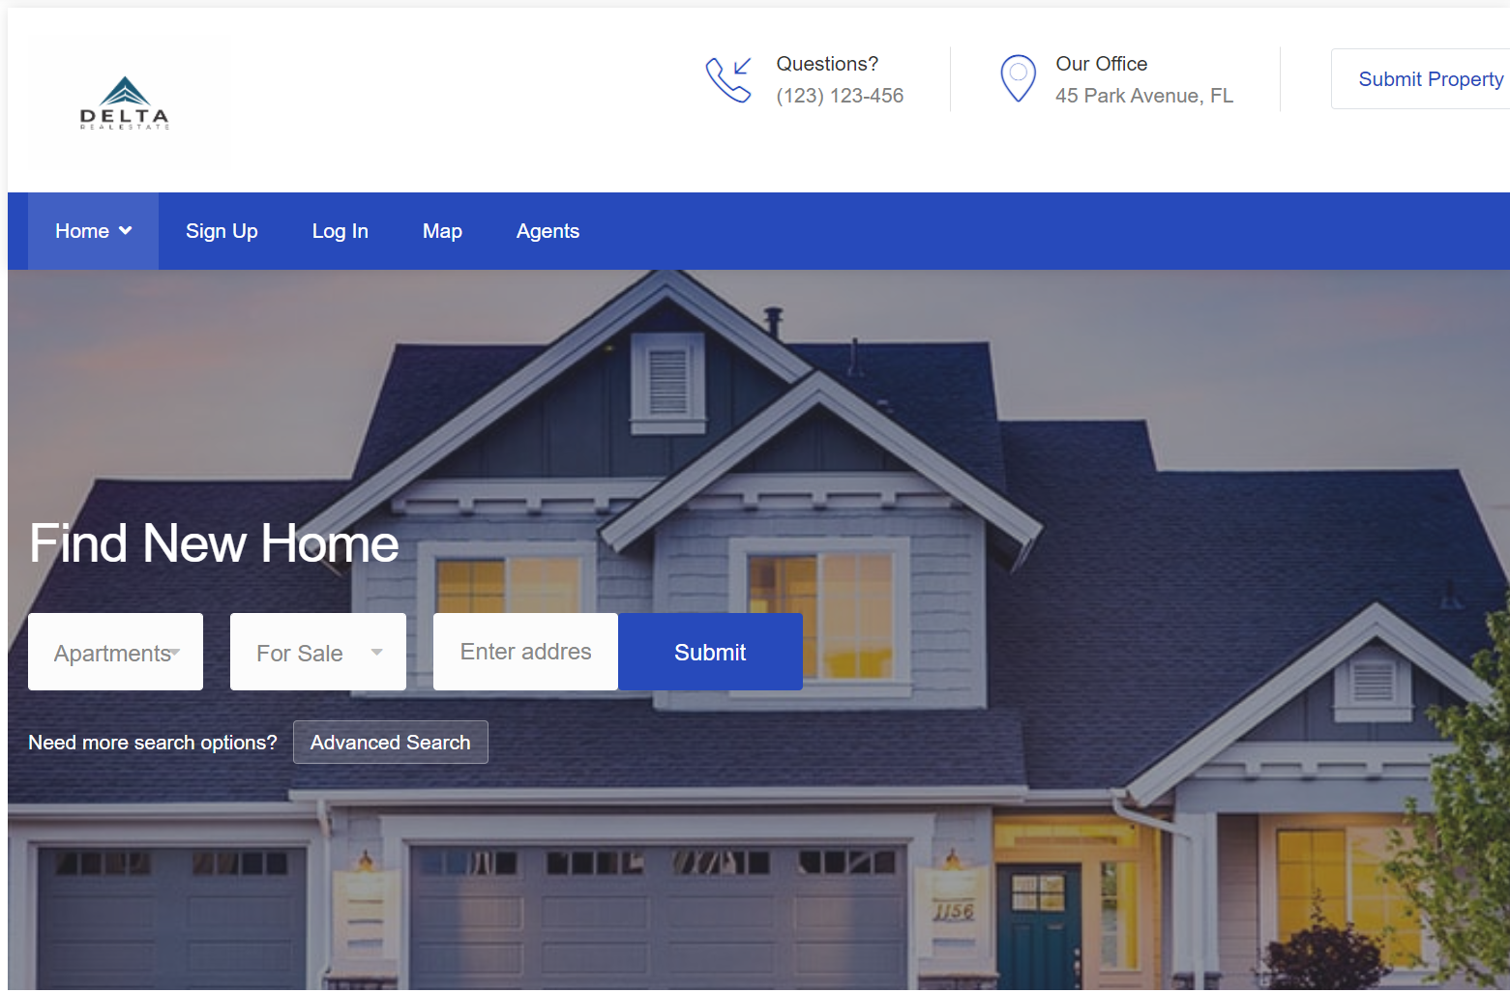

### Header

The header contains our logo as well as all of the information that is essential for contacting the company. It contains our phone number, office email, and social media accounts. The big “Submit Property” function is for users who want to sell and rent to submit their property information. 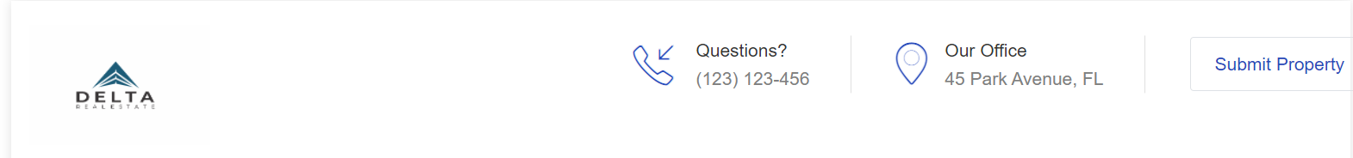

How: we input our logo image into the right corner, and write html codes for contact information.

the “Submit Property” button will redirect our web page to the “Submit Property” page. we just use the input submit button for html to achieve this.

### *Menu*

The menu allows users to navigate, buy, sell, and rent pages. This will also allow the user to login and create an account.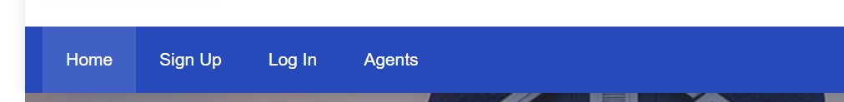

How: We created a menu bar with four buttons which can direct our user into four different pages. Each one of them is a button with redirection links in HTML to our “Index”, “Sign up”, “Login”, and “Agents List” page.

### Search Section

This is our first main function of this project: the search function. The search field contains 3 ways to search for properties: Property Type, For Sale/For Rent, and any keywords which will match . 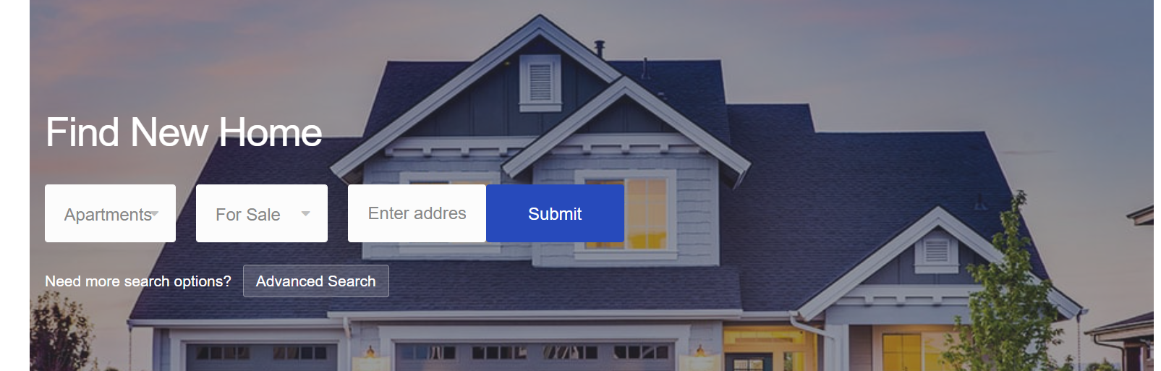

How: In HTML page, we used ASP action to get user’s input(listingType, PropertyType, address),

we first built a SearchService.cs, it will check the string that database returned, then compare it with user’s input, if the listing and property type matched, and the Street, City, State attribute match or contains any character from our address string, the correct string will be returned.

### *Mission Statement:*

Our goal is to allow our clients to find a home in an area that will let them build their dream life! The first step is to decide where they would like to move, and then they could go from there.

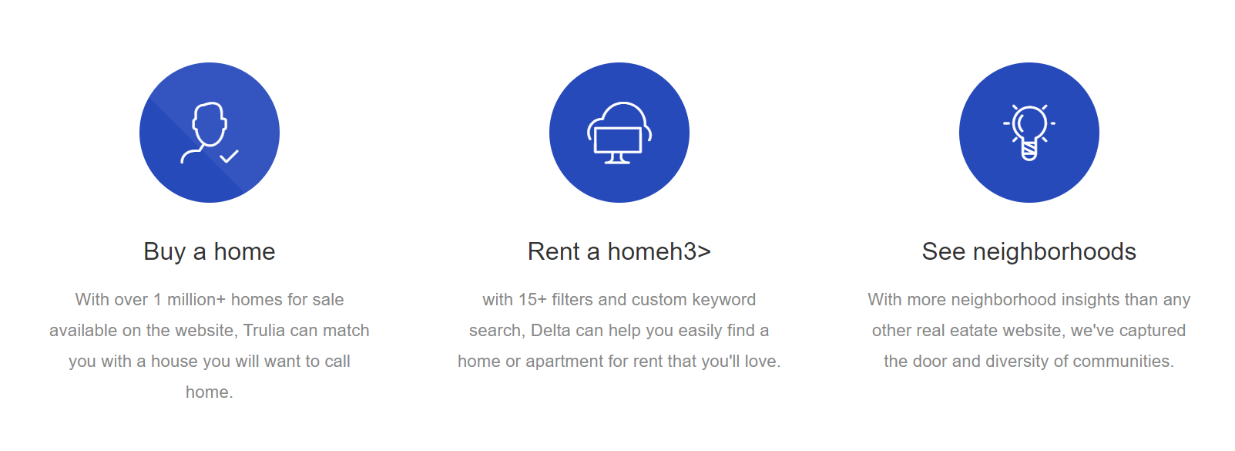

How: these parts are static html, we used three icon images and some paragraphs.

### Recommendation and Demonstration

The recommendation and demonstration section allows users to view recommendations of various properties based on their location. This section also includes items that were recently added to our database so that the user can see properties that were entered in the market.

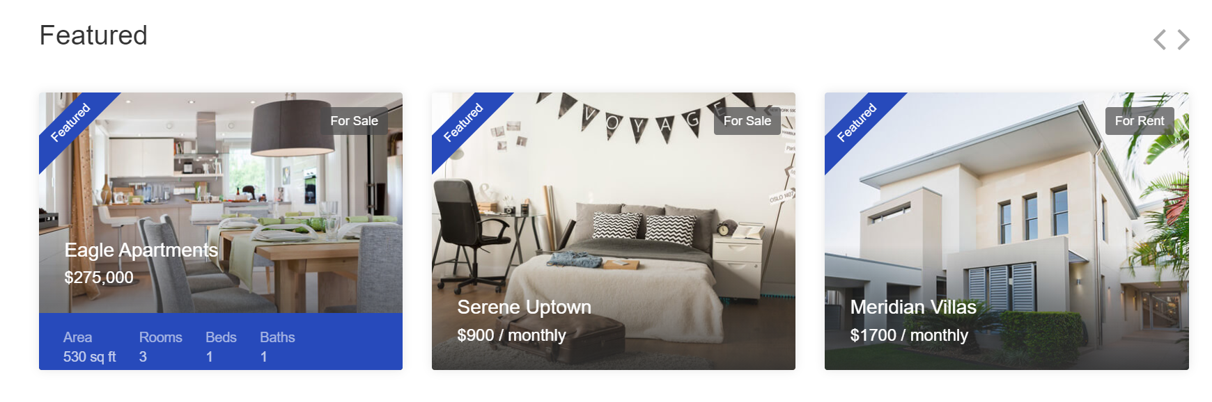

How: This demonstration section will randomly pull three properties from our house database table, then it demonstrates the house’s attributes as a picture. each picture is clickable, and it will redirect the user into the specific house’s “Show Details” page.

### Footer section:

The footer allows our users to have an alternative way to gain access into our different pages as shown. It’s convenient for the users, so they don’t have to scroll up all the way into headers or the menu bar to access or view contact information. 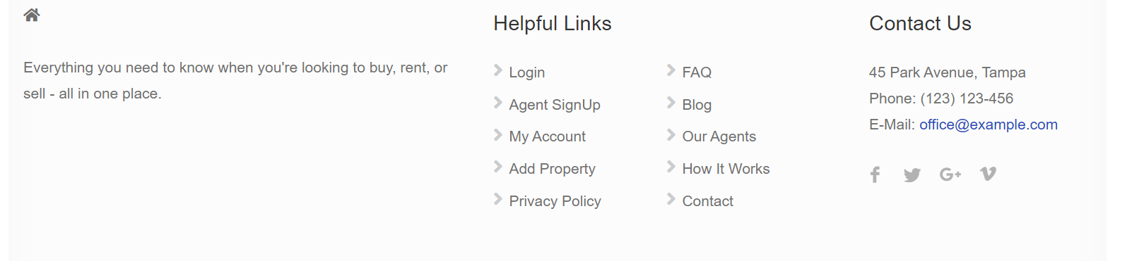

How: these listed buttons have the same redirection action as them in the header section.

## Map and Advanced Search

### Purpose

The purpose of the “ShowMap” page is to allow users to see the search results in google map view and update more filters if applicable.

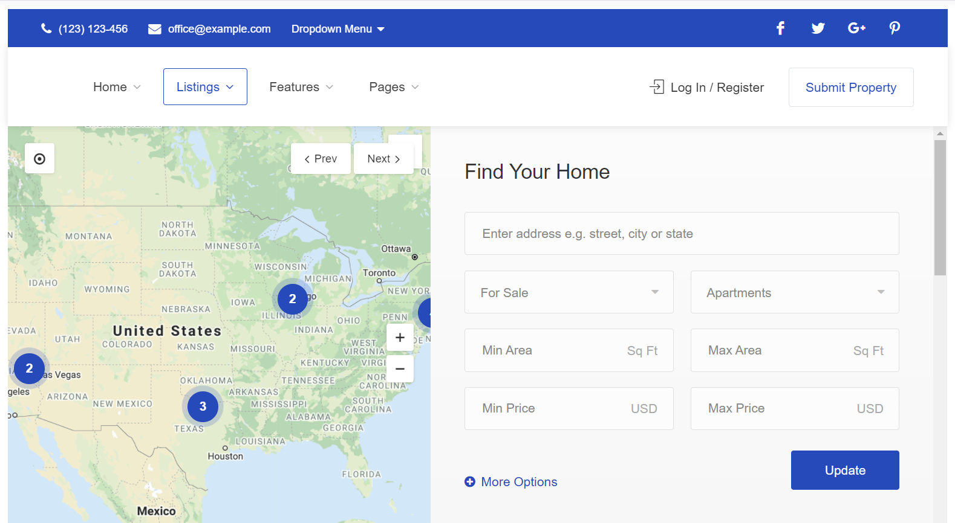

How: the users can search more filters based on the property’s attributes. Everytime users click on the update, it will implement the same search service we used on the home page but with more options. The returned results(coordinates) will be passed into the google map locationData with marker function. Eventually, it will be shown on the map with the user’s search results.

### Map Section

This section will show the search results in a Google Map and mark them. The user can zoom in and out, or click on the next or previous button to view results if there are multiple ones.

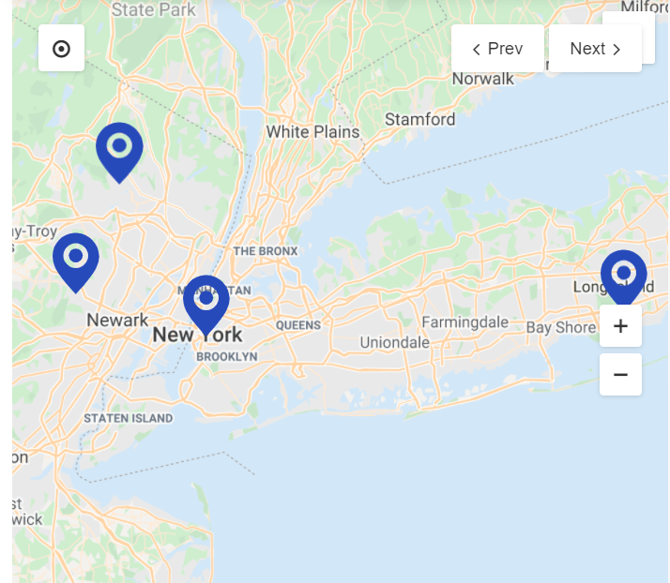

How: we used a google map api to achieve this function. We have generated a key for this map. When the user clicks on the “Submit” button from the Home page, it will be redirected to here. Then we extract the street, city, state, and zip code from the address string and use the “GeoCoding” from google to convert the address into latitude, and longitude.then we call the google map api, input the coordinates data, and it find our place. We also implemented the zoom in and zoom out function inside our map script as well as previous and next, So the users can adjust as they wish.

### Advanced Search Section

The advanced search function allows the user to narrow their results for properties based on filters, such as square feet, number of bathrooms and bedrooms, and garage size. The find agents button allows users to talk with an agent. The map function allows the user to view a map of the property they have currently selected.

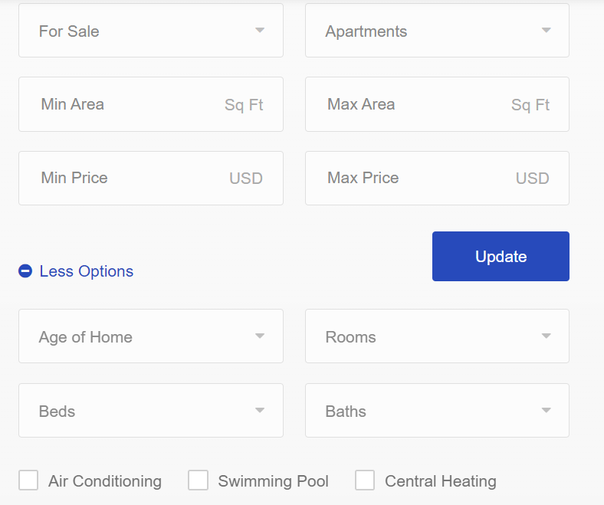

whatever we received from either search and update will be demonstrated like the following:

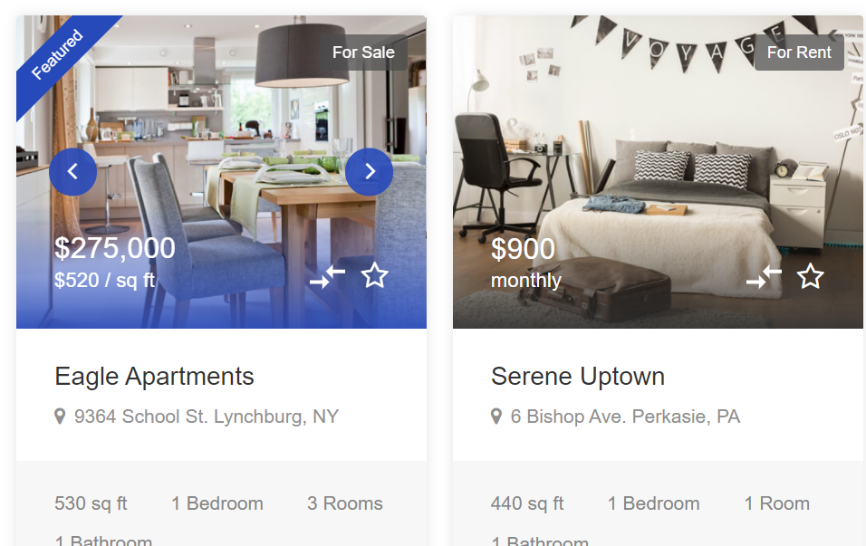

## Detailed Single Property Page

### Purpose

The Purpose of the “ShowDetail” page is to allow the user to view one single property on details. they could view from different pictures and every related details.

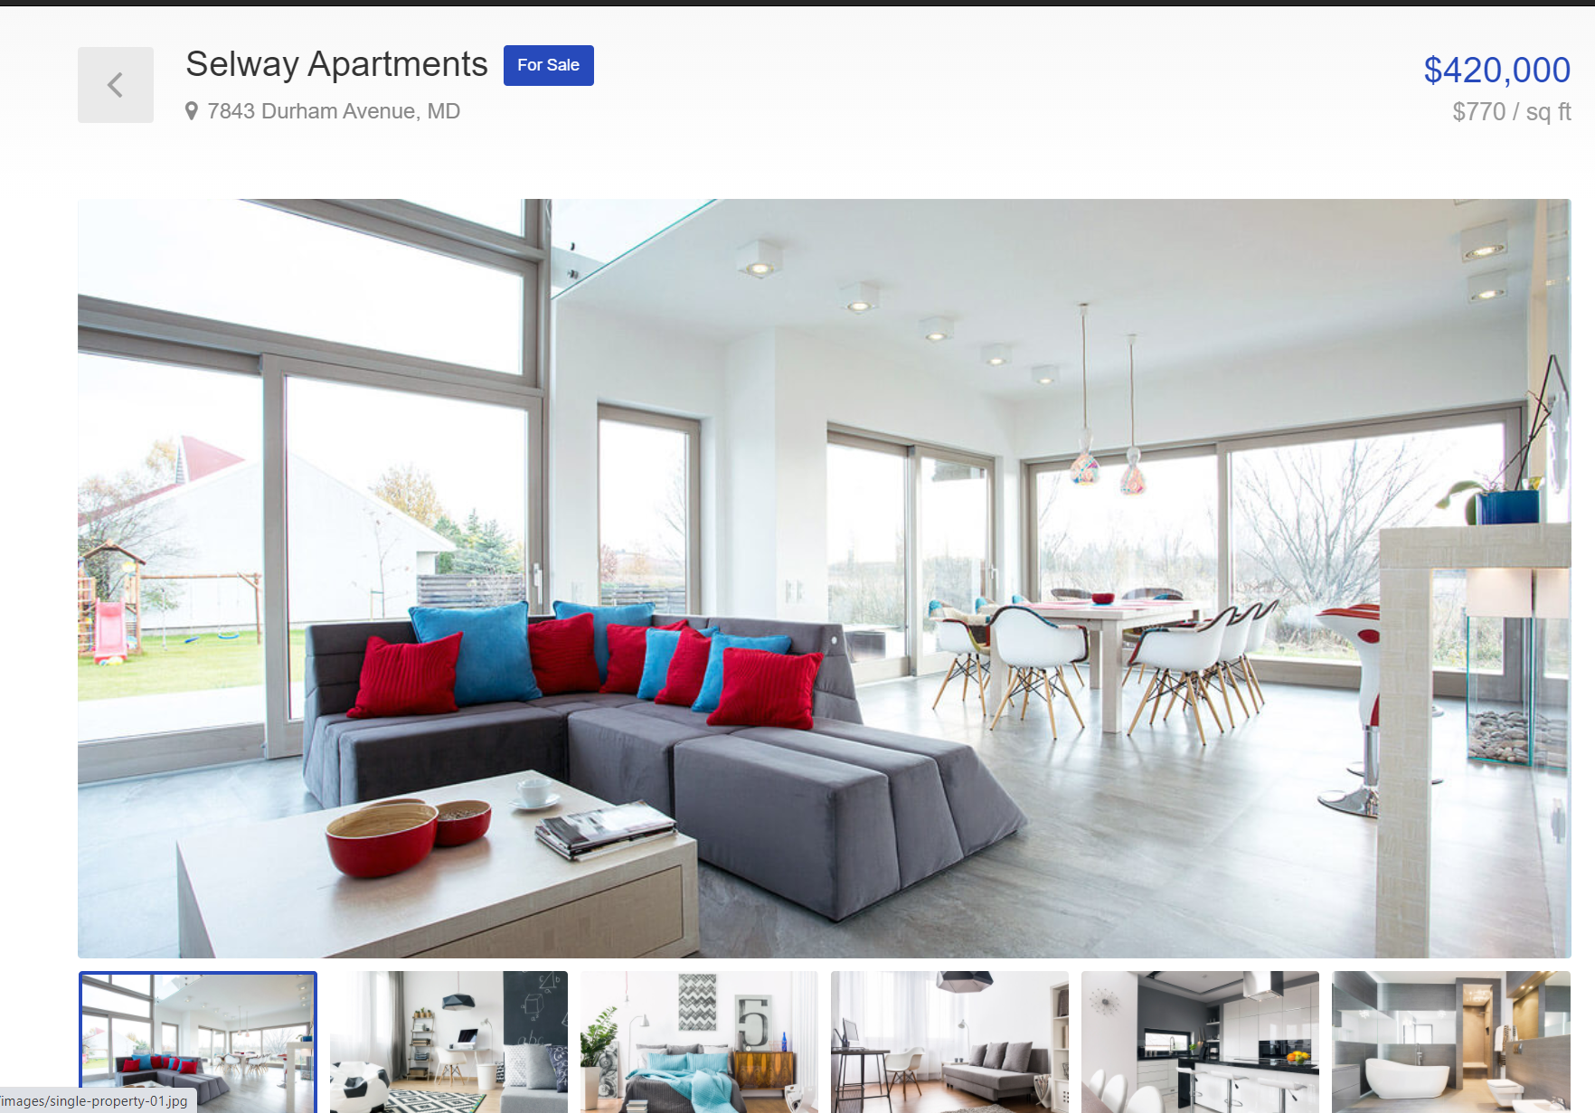

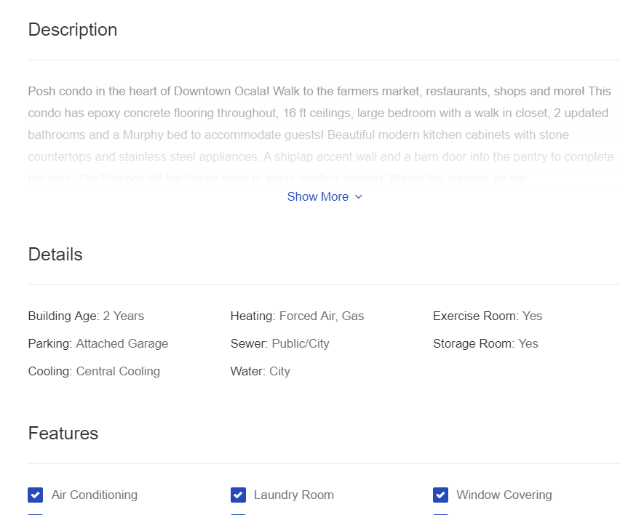

How: we will pull every attribute regarding that property from our database, and show it on the webpage.

## Login and Register Page

Our login section will allow our clients to enter our website through typing in their username and password. Once they click login, their account will be created and sent back to our database. 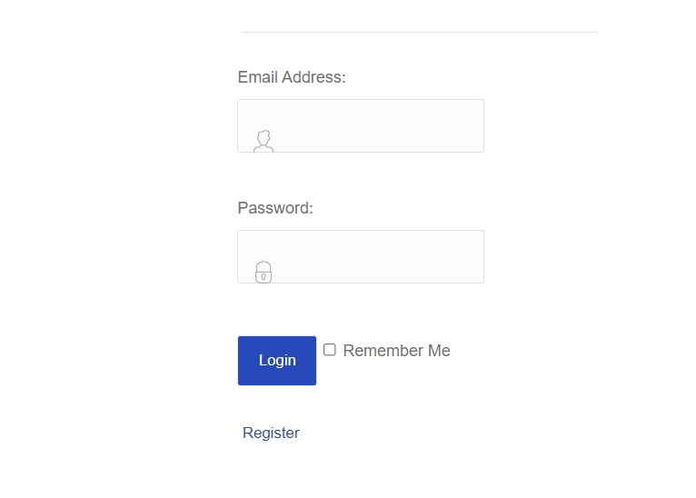

How: we create a login model to get and set the data. then we create a controller, we will use a validateUser function to compare the data with what we have in the database, if there's a match, the user will be successfully logged in. if not, an error message will be displayed. any security data will be encrypted for safety.

Our register section will allow our clients to register their account if they don’t have one.

Once they click login, their account will be created and sent back to our database.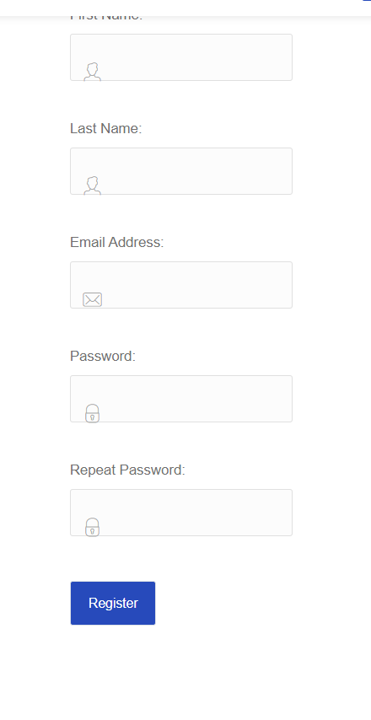

How: First we used an RegisterViewModel to create these properties, when users register, it will pass back to our database and store into corresponding attributes. password will be encrypted and hidden, see more details on security section.

## Submit Property page

This page will allow users to submit property information with different attributes.

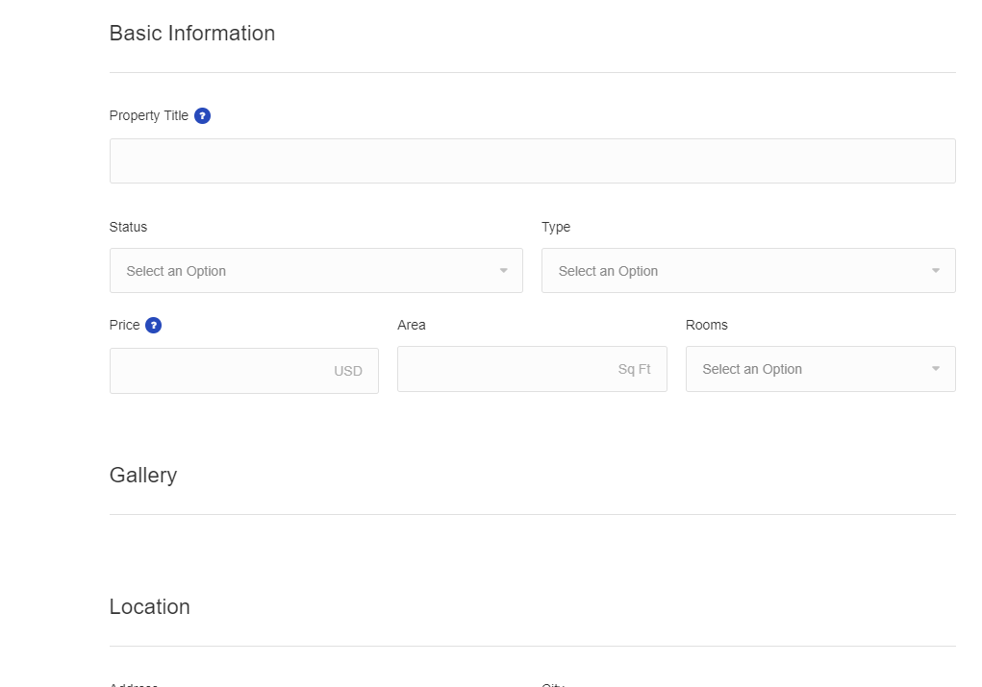

How: we use an authentication service to check if the user who clicks on the submit button is logged in. if yes, the submit property page will be open, and any data user enters will be linked with them. if not, it will redirect to the login page for users to log in.

## Agent Sign Up Page

The agent sign up page is designed for creating an agents account, the agent will be linked with responsible customers and corresponding property.

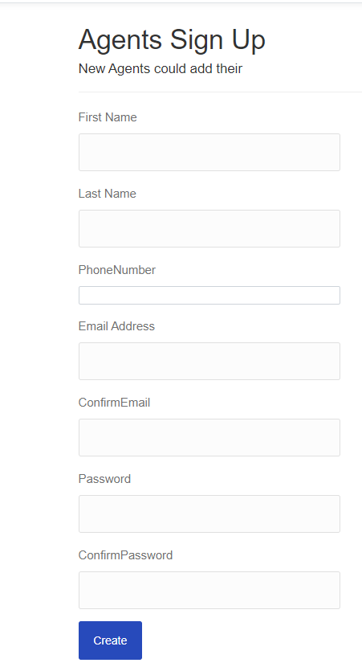

How: we create an agent model to get and set these properties, when users hit create, the data will be passed back to our database. it will have foreign keys linked with the users table and property table.

## Agent List

The agent list allows users to search for an agent based on their name or location. Delta users can find information about the agents such as their email address, phone number, and social media accounts.



How: Simply pulls our agent data from our database and displays them on the page.

# Database

## Database Framework

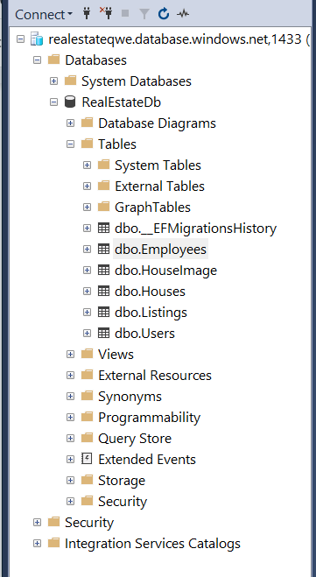

We used C# in ASP.NET Core framework to create the database, and it will automatically convert C# commands into SQL commands.

## Security Setting

1. We configured Https when we create the project, it will require Https for all requests and redirect all Http requests to Https. 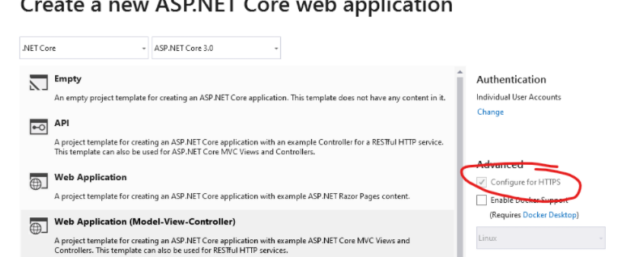

1. By using the AntiForgeryToken() security feature, it can protect our application against cross-site request forgery. 
2. For all the passwords,we first used type equal “password”, so when the user is typing the password, it is hidden and can’t be seen.

1. When storing the passwords, we used an encrypted and decrypted algorithm. Therefore during passing the passwords between database and webpage, it will be encrypted. when we pull the data out from our database, we decrypt it. when checking the passwords in our database, it will show as random characters. 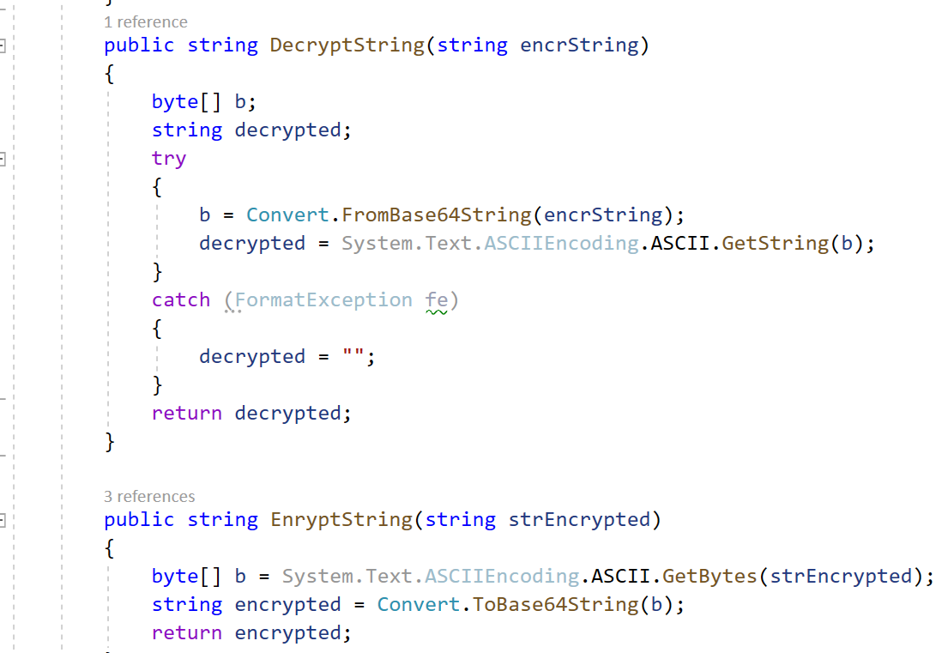

## Server Management

*We set up our server on azure, and it connected with our database. 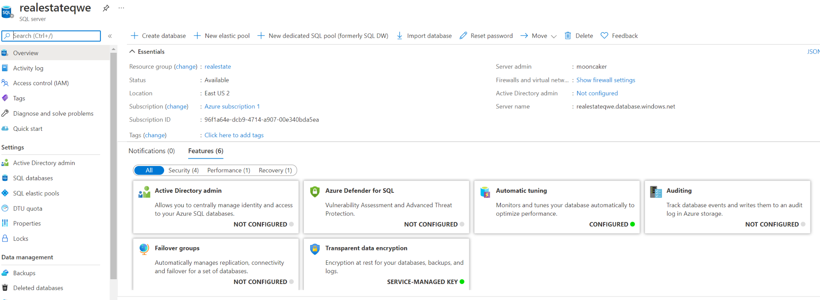*

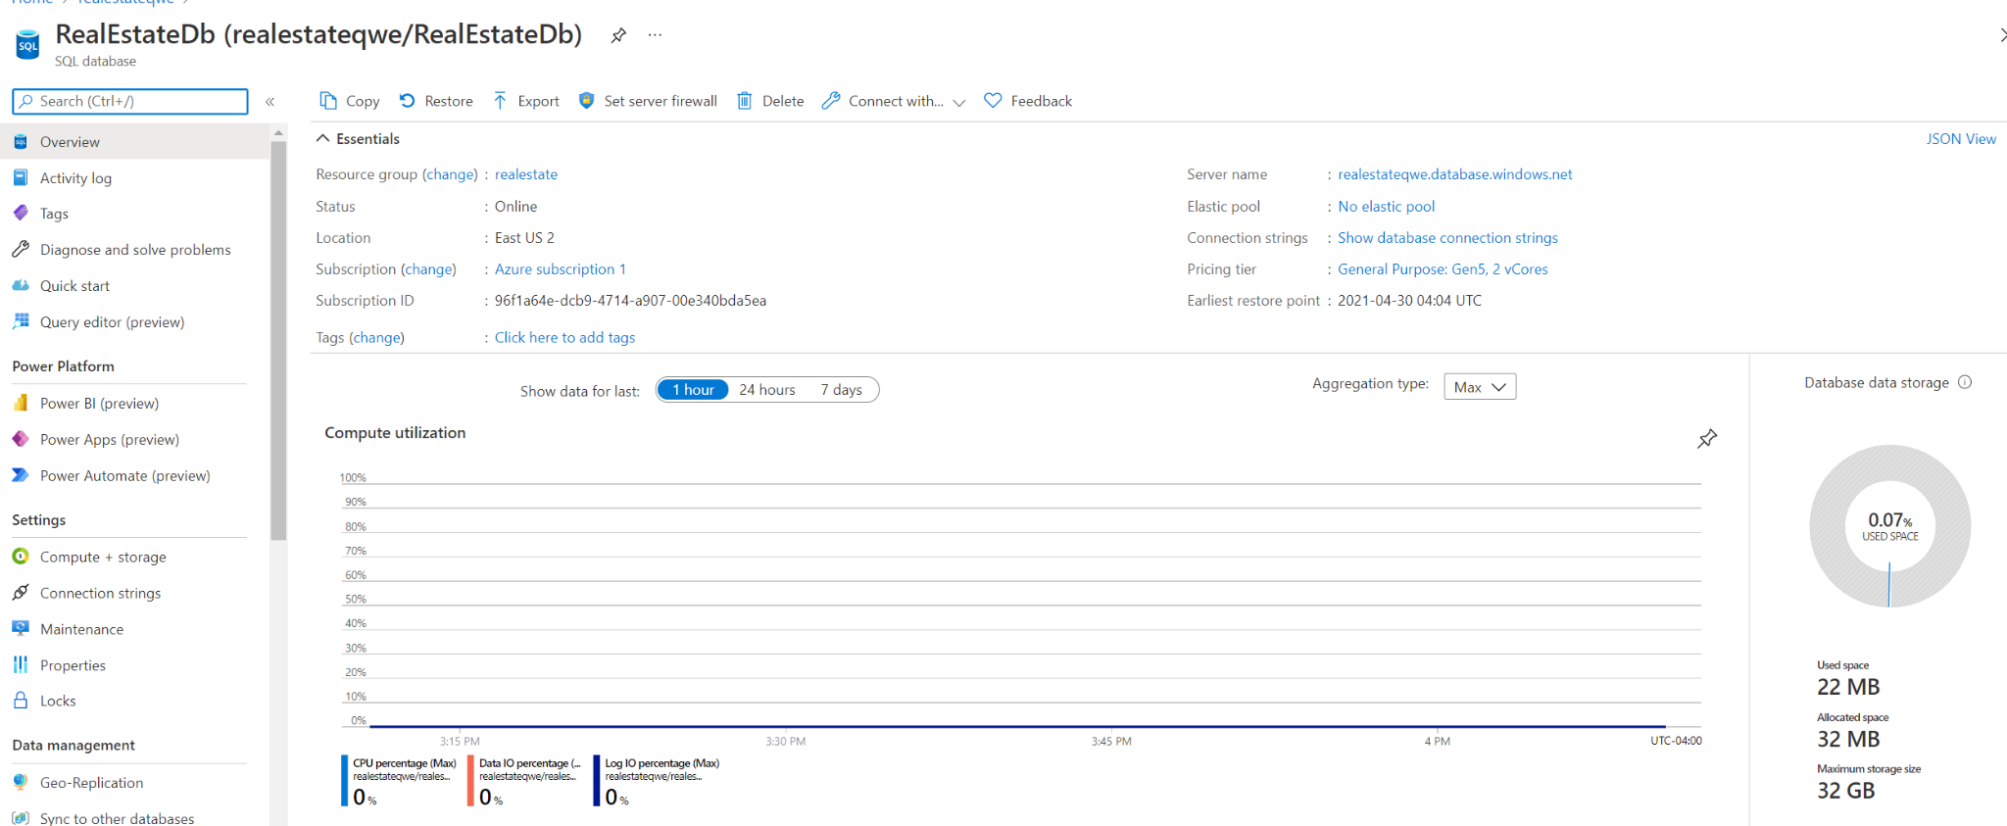

## References

We have studied and inspected some real estate’s website Html layout. We have also used some CSS and JavaScript from a themeforest template, we have paid and acquired the copyright of it for non business use. We also used Google maps api code and other related code from Google developer website. We also studied and used resources from Microsoft .Net frame tutorial section.

1. “Findeo - Real Estate HTML Template Preview,” *ThemeForest*, 2016. [Online]. Available: http://preview.themeforest.net/item/findeo-real-estate-html-template/full_screen_preview/18936684?_ga=2.18023801.192172027.1619636429-1984697807.1619636410. [Accessed: 03-May-2021].
2. R. Barton and S. Rascoff, *zillow.com*, Feb-2006. [Online]. Available: https://www.zillow.com/. [Accessed: 03-May-2021].
3. R. Ali, J. Appelman, and J. Archibald, *Google Maps Platform | Google Developers*, 17-Mar-2005. [Online]. Available: https://developers.google.com/maps. [Accessed: 03-May-2021].
4. “Learn .NET: Free tutorials, videos, courses, and more,” *Microsoft*, 2016. [Online]. Available: https://dotnet.microsoft.com/learn. [Accessed: 03-May-2021].
5. Cross, B. (2011, February 7). Software Requirements Specification For Real Estate Website. Retrieved January 29, 2021, from https://docplayer.net/17250352-Software-requirements-specification-for-real-estate-web-site.html